Project Report
On
UNi Demands
Submitted in the partial fulfilment of the requirement for the award of degree of
Bachelor of Technology
in
Computer Science and Engineering
Batch (2022-2026)


Submitted to: Submitted by:
Ms. Mehak Kohli Amrik Singh
Assistant Prof. CSE 12200252

DEPARTMENT OF COMPUTER SCIENCE AND ENGINEERING DAV UNIVERSITYJALANDHAR-PATHANKOT NATIONAL HIGHWAY, NH44, SARMASTPUR PUNJAB-14401
DECLARATION

I, Amrik Singh, hereby declare that the work which is being presented in this project/training titled Uni Demands by me, in partial fulfilment of the requirements for the award of Bachelor of Technology (B. Tech) Degree in “Computer Science and Engineering” is an authentic record of my own work carried out under the guidance of Ms. Mehak Kohli (Assistant Prof. CSE).

To the best of my knowledge, the matter embodied in this report has not been submitted to any other University/ Institute for the award of any degree or diploma.

Ms. Mehak Kohli Amrik Singh
Assistant Prof. CSE 12200252

ABSTRACT

Uni Demands is a web-based ordering and management system designed to streamline the process of browsing and purchasing products associated with universities and their departments. Built using the MERN stack (MongoDB, Express.js, React.js, and Node.js), the system provides a secure, scalable, and efficient platform that connects users with multiple universities, departments, and their available products in a centralized digital space.
The application features two main roles — Admin and Users. Admins can manage universities, departments, products, user accounts, and order details through a dedicated dashboard. Users can explore products, add items to the cart, submit orders, make payments, and track order status in real time. The system further enhances the user experience with functionalities like email and SMS notifications for order confirmation and status updates.
This system has two panels.
- Admin
- Users

ACKNOWLEDGEMENT

I would like to express my sincere gratitude to my project guide Ms. Mehak Kohli, for their valuable guidance, constructive feedback, and continuous support throughout the duration of this project. I am also thankful to Dr. Rahul Hans and the Department of Computer Science & Engineering for providing the necessary resources and an encouraging academic environment.
My appreciation extends to all faculty members and classmates whose suggestions and cooperation helped strengthen the quality of this work. Lastly, I am deeply grateful to my family for their constant encouragement and support, which motivated me to complete this project successfully.

Table of Content
CHAPTER 1: INRODUCTION
1.1 Introduction of Project Report
1.2 Introduction to Project
CHAPTER 2: PROJECT TITLE AND OVERVIEW
2.1 Project Title
2.2 Project Overview
2.3 Objectives
CHAPTER 3: TECHNOLOGIES USED
3.1 Frontend
3.2 Backend
3.3 Tools Used
CHAPTER 4: Software Development Life Cycle Model
4.1 Introduction to SDLC
4.2 SDLC Model Used
4.3 Phases of Sdlc
CHAPTER 5: System Design and Requirements
5.1 System Architecture
5.2 Data Flow diagram (DFD)
5.3 System Requirements
Chapter 6: Testing, Maintenance, and Results
6.1 Testing
6.2 Maintenance
6.3 Results
CHAPTER 7: Conclusion and References
7.1 Conclusion

CHAPTER 1-INRODUCTION
1.1 Introduction of Project Report
The project report is a comprehensive document that provides detailed information about the proposed project, UNi Demands. It serves as a blueprint for all operations, outlining the goals, objectives, and strategies to transform this innovative idea into a functional and productive platform. The report acts as a guide to ensure clarity and direction in the execution of the project.
Project reports play a crucial role for both project teams and stakeholders, offering a clear overview of the project's progress and alignment with the original plan. Through these reports, potential risks can be identified early, and corrective actions can be implemented. The report for UNi Demands includes a breakdown of operations, cost estimates, and expected outcomes, ensuring all stakeholders have a clear understanding of the project's scope and profitability. By providing these insights, the report ensures that the development and implementation of UNi Demands remain efficient and goal-oriented.
Here are the points that validate the Importance of Project Report:

- Project reports are an important source for managers and stakeholders, to monitor the current progress and measure against the original schedule.

- It helps to predict the threats and develop proper steps to recover.

- There port makes it easier to control the co-stand budget apart from the budgeted cost.

- It will be a source of information to respond to success, stagnation, team results, or quality of work.

- The project report requires completeness and accuracy, also ensures coverage of all dimensions of the project, makes the data more viable.

- It helps the project manage to deal with potential or upcoming risks during projects.

- The report increases the amount of visibility into your projects and will give you full insight into how your project is performing.

- It helps the entrepreneur to get an exact idea about the initial inputs required for the business.

Introduction to Project
Uni Demands is developed as an advanced web-based solution to overcome these challenges by digitalizing the entire product ordering and management cycle within and across universities. Through a centralized online platform, users can browse universities, explore their departments, and access the list of products available under each category. The ordering process becomes efficient, user-friendly, and structured — from browsing products to final delivery and payment.

CHAPTER 2- PROJECT TITLE AND OVERVIEW

2.1 Project Title – Uni Demands

2.2 Project Overview –
Uni Demands is a full-stack university product and department ordering system developed to digitalize and simplify the process of accessing and purchasing educational products across various universities and their departments. The platform introduces a structured and centralized approach to product management by offering role-based access for two primary users: Admins and Students/Users.
Built using the MERN stack (MongoDB, Express.js, React.js, and Node.js), Uni Demands delivers a secure, scalable, and responsive environment for managing the complete order workflow. Admins can add and manage universities, departments, and their respective products, track user orders, and communicate order updates in real time. Users can register, log in, explore universities and departments, view available products, add items to the cart, place orders, make payments, and monitor their order history and delivery progress.
The system provides advanced features such as JWT-based secure authentication, protected routes, product image uploading, SMS and email notifications for order confirmation, and integrated payment services, ensuring a complete and practical solution ready for real-world institutional use. Pagination and search capabilities enable smooth navigation even when large volumes of universities, departments, and products are present.
The platform consists of two primary user roles: Admin and User.
- Admin Panel:
The Admin Panel in UNi Demands functions as the central management system responsible for controlling the overall workflow of universities, departments, products, and user orders. Admins are provided with complete access to all core backend and frontend functionalities, enabling them to maintain a smooth operational flow throughout the system.

      - Add and manage universities, departments, and products, including details like names, descriptions, prices, and images.
      - Oversee and track user orders, including order status updates like pending, approved, shipped, and delivered.
      - Monitor the inventory and product availability in different departments under multiple universities.
      - Manage user accounts, providing options to add, update, soft delete, or permanently remove users from the platform.
      - Send and manage order updates and notifications for better communication and transparency.
      - Access real-time system statistics such as total users, total products, total orders, and revenue insights through secure APIs and structured dashboards.
The Admin Panel is designed to ensure complete control, operational transparency, and centralized management across the system. By simplifying institutional product handling and reducing manual dependency, it creates a more reliable, organized, and efficient workflow for both administrators and end-users.
2. Employee Panel:
The User Panel in Uni Demands is designed to provide students and general users a smooth and structured experience for browsing, ordering, and tracking products related to universities and their departments. It streamlines the entire product purchasing process with an intuitive interface, ensuring convenience, transparency, and real-time interaction.
Key functionalities include:
      - Register and log in securely using authentication-enabled access control.
      - Browse universities and departments, and explore all available products with complete details such as name, description, price, and images.
      - Add selected products to the shopping cart for later review or immediate checkout.
      - Place orders with secure transaction flow, including address details and selected payment method.
      - Receive real-time SMS and email notifications after order placement and during delivery status updates.
      - View order history and current order status, such as pending, approved, shipped, and delivered.
      - Update personal profile information and manage account settings with user-friendly tools.
The User Panel ensures a comfortable, transparent, and digitized experience for purchasing educational products. By eliminating manual purchasing challenges and providing real-time order tracking, Uni Demands empowers users with a fast, organized, and fully accessible academic shopping environment.

2.3 Objectives
- To digitalize the purchasing process of university and departmental products by replacing traditional manual workflows with a centralized online system.
- To provide a user-friendly platform where students and users can easily browse universities, departments, and products from a single interface.
- To enable efficient product management for admins by allowing the addition, updation, and removal of universities, departments, and related products.
- To provide a secure ordering system with authentication and protected routing to ensure safe user access and transaction flow.
- To simplify order tracking by providing real-time order status updates such as pending, approved, shipped, and delivered.
- To enhance communication transparency through automated email and SMS notifications for order confirmation and delivery updates.
- To reduce operational load on educational institutions by automating product listing, inventory tracking, and order management.
- To improve user convenience by offering features like cart management, product search, pagination, and responsive UI.
- To maintain accurate digital records of users, products, and orders through a secure and scalable database structure.
- To create an efficient and reliable e-ordering ecosystem that improves accessibility, speeds up workflows, and leads to greater user satisfaction.

CHAPTER 3 – TECHNOLOGIES USED
3.1 Frontend:
- HTML: HyperText Markup Language
HTML (Hypertext Markup Language) is the standard language used to create and design webpages. It forms the backbone of all web content by structuring web pages with elements such as headings, paragraphs, images, links, tables, and lists. HTML is not a programming language in the traditional sense but a markup language used to define the structure of web content.
Key Points:
- Elements and Tags: HTML uses tags to define various parts of a webpage. Each element is enclosed in opening and closing tags (e.g., <h1> for headings, <p> for paragraphs).
- Hyperlinks: One of the main features of HTML is its ability to link web pages through hyperlinks using the <a> tag. This allows navigation between pages and websites, forming the web's "hypertext" structure.
- Multimedia Integration: HTML allows the integration of images, videos, audio, and other media types through tags like <img>, <video>, and <audio>, making webpages interactive and engaging.
- Forms and User Input: HTML forms are used to collect user input such as text, passwords, checkboxes, and radio buttons. These forms can be submitted to the server for processing and storage.
- Document Structure: HTML defines the overall structure of a webpage with essential components like the <head> (containing metadata, links to stylesheets, scripts) and <body> (containing the content to be displayed on the page).

Importance of HTML in Project:
HTML is important in Uni Demands because it forms the basic structure of every page. All UI elements like forms, buttons, product listings, and navigation are built with HTML, making it the foundation on which styling and functionality work.



- CSS: Cascading Style Sheets
CSS (Cascading Style Sheets) is a style sheet language used to control the visual presentation of a web page written in HTML or XML. While HTML provides the structure of a webpage, CSS is responsible for styling it, including layouts, colors, fonts, and overall design. CSS allows developers to create visually appealing and responsive websites that adapt seamlessly to different screen sizes and devices.
Key Points:
- Styling Elements: CSS controls the appearance of HTML elements, such as changing font styles, sizes, colors, and spacing to improve readability and design.
- Layouts and Positioning: CSS enables precise control over the positioning and layout of elements on a page using properties like margin, padding, flexbox, and grid.
- Responsive Design: With features like media queries, CSS ensures that websites look good on devices of all sizes, from desktops to smartphones.
- Cascading Rules: CSS follows a "cascading" order of rules, meaning styles can be inherited, overridden, or specified using selectors and priorities.
- Animation and Interactivity: CSS supports animations and transitions, enabling developers to create interactive visual effects without relying on JavaScript.
- Separation of Concerns: CSS keeps styling separate from HTML content, improving maintainability and allowing developers to reuse styles across multiple pages.

Types of CSS:
- Inline CSS: Styles applied directly to an HTML element using the style attribute.
Example: <p style="color: red;">This is red text.</p>
- Internal CSS: Styles written inside a <style> tag within the HTML <head>.
Example: <style> p { color: blue; } </style>
- External CSS: Styles written in a separate .css file and linked to the HTML document.
Example: <link rel="stylesheet" href="styles.css">

Importance of CSS in Project:

CSS is important in Uni Demands because it controls the visual design and appearance of every page. It makes the interface attractive and user-friendly by managing layout, colors, spacing, animations, and responsiveness, ensuring a smooth experience on all devices.

- Bootstrap:
Bootstrap is a popular open-source front-end framework used for developing responsive and mobile-first websites. It was initially developed by Twitter and is now maintained by the open-source community. Bootstrap combines HTML, CSS, and JavaScript components to create visually appealing and functional web pages with minimal effort. The server-side of web development involves handling business logic, database operations, and server communication.
Key Points:
- Responsive Design: Bootstrap is built on a mobile-first approach, ensuring that web pages are responsive and adapt seamlessly to various screen sizes, from desktops to smartphones.
- Pre-designed Components: It offers a wide range of reusable UI components like navigation bars, buttons, forms, modals, and carousels, which can be easily customized and integrated into projects.
- Grid System: The framework includes a powerful 12-column grid layout system for creating flexible and responsive layouts.
- Customizable Themes: Bootstrap allows developers to easily customize themes, colors, and typography to match the desired design.
- Cross-Browser Compatibility: Bootstrap ensures that web pages look and function consistently across different browsers.
- JavaScript Plugins: It includes built-in JavaScript plugins (e.g., tooltips, dropdowns, modals) to add interactivity without writing extensive custom scripts.

Importance of Bootstrap in Project:

Bootstrap is important in Uni Demands because it provides pre-built responsive layouts and UI components, helping to design pages quickly and consistently. With ready-made grids, buttons, forms, and utilities, the interface becomes clean, scalable, and mobile-friendly without writing large custom CSS.


- JavaScript:
JavaScript (JS) is a high-level, versatile, and lightweight programming language primarily used to create dynamic and interactive web applications. It is one of the core technologies of the web, alongside HTML and CSS, enabling developers to enhance user experiences by adding interactivity to websites. JavaScript can run both on the client-side (in the browser) and server-side (using environments like Node.js).
Key Points:
- Interactivity: JavaScript allows developers to add interactivity to web pages, such as dropdown menus, sliders, pop-ups, and form validation.
- DOM Manipulation: JS can dynamically update and manipulate the HTML and CSS of a webpage, enabling features like live content updates without refreshing the page.
- Cross-Browser Compatibility: JavaScript works across all major web browsers, making it essential for building interactive web applications.
- Event Handling: JavaScript allows developers to respond to user actions like clicks, hover, and input using event listeners.
- Extensibility with Libraries and Frameworks: Popular libraries (e.g., jQuery) and frameworks (e.g., React, Angular, and Vue.js) extend JavaScript's capabilities, simplifying and accelerating development.
- Server-Side Programming: With platforms like Node.js, JavaScript can be used to build scalable server-side applications.
- Asynchronous Operations: JavaScript supports asynchronous programming using features like Promises, async/await, and AJAX, enabling smooth data fetching and background operations.

Importance of JavaScript in Project:
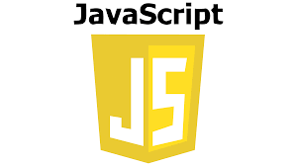
JavaScript is important in Uni Demands because it adds interactivity and dynamic behavior to the system. It enables real-time updates, form validation, API communication, and responsive actions, making the user experience smooth and functional beyond just static pages.

- React.js + Vite:
React.js is a popular open-source JavaScript library used for building user interfaces, especially single-page applications (SPAs). Developed and maintained by Meta (formerly Facebook), React focuses on creating dynamic and responsive web applications with high performance and a seamless user experience. React's component-based architecture makes it easy for developers to build reusable and maintainable UI elements.
Vite is a modern build tool and development server that significantly improves the React development experience. Compared to traditional tools like Create React App (CRA), Vite offers faster startup time, instant hot module replacement (HMR), and lightweight build configurations.

Key Features of React.js + Vite:
- Fast Development Start-up: Vite offers significantly faster server initialization compared to traditional tools such as Create React App. This improves the development workflow and reduces waiting time during project setup.
- Hot Module Replacement (HMR): With HMR, changes made to the code reflect instantly in the browser without requiring a full page reload. This allows for seamless testing and debugging while preserving the application state.
- Optimized Production Builds: Vite uses Rollup as its build tool, producing compact, tree-shaken, and highly optimized bundles for deployment. This ensures that the application runs efficiently in production environments.
- Minimal Configuration: Vite comes with pre-configured settings, reducing the need for complex manual configurations. This enables developers to focus on core functionality rather than setup
- Lightweight and High Performance: The overall performance of applications built with Vite is enhanced due to smaller bundle sizes and faster reloading during both development and production stages.
- Rich Ecosystem: React has a vast ecosystem of libraries and tools, such as React Router for routing and Material-UI for pre-designed components.

Importance of React.js + Vite in Project:
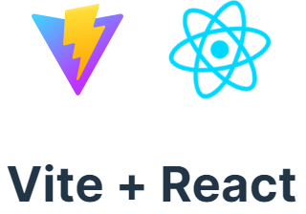
React + Vite are important in Uni Demands because they make the frontend fast, interactive, and efficient. React handles dynamic components and real-time updates, while Vite provides a super-fast development environment and optimized production build. Together, they improve performance, speed up rendering, and deliver a smooth and responsive user interface.

3.2 Backend:
- Node.js:
Node.js is an open-source, cross-platform runtime environment that allows developers to run JavaScript code on the server side. Built on Google Chrome’s V8 JavaScript engine, Node.js is lightweight, efficient, and designed for building scalable and high-performance network applications. It is particularly well-suited for real-time applications and APIs due to its non-blocking, event-driven architecture.

Key Points:
- Asynchronous and Event-Driven: Node.js operates on a non-blocking I/O model, meaning it can handle multiple requests simultaneously without waiting for one to complete.
- Single-Threaded Architecture: While single-threaded, Node.js uses an event loop to manage concurrent operations efficiently, making it highly scalable.
- Fast Execution: Powered by the V8 engine, Node.js executes JavaScript code at high speed, making it ideal for real-time applications.
- Cross-Platform: Node.js runs on Windows, Linux, macOS, and other platforms, making it versatile for various development environments.
- Built-In Modules: Node.js comes with a set of core modules, such as http, fs (file system), and path, that simplify backend development tasks.
- Package Ecosystem (npm): Node.js has the largest package ecosystem through npm (Node Package Manager), offering thousands of reusable libraries and tools.
- JSON Support: Node.js works seamlessly with JSON, making it an excellent choice for building RESTful APIs.

Importance of Node.js in Project:
Node.js is important in Uni Demands because it handles the backend logic and API processing with high speed and scalability. It manages user requests, authentication, order handling, and database communication efficiently, making the system secure, reliable, and capable of handling multiple operations smoothly.
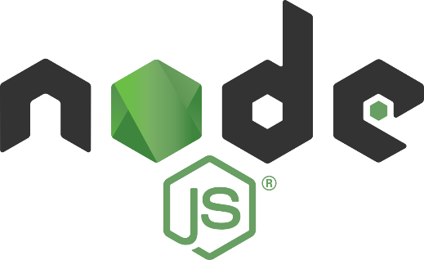

- Express.js:
Express.js is a fast, unopinionated, and minimalist web application framework for Node.js, widely used for building server-side applications and RESTful APIs. It simplifies the process of managing server logic, handling routes, processing HTTP requests, and integrating middleware for authentication, validation, and error handling.

Key Points:
- Minimal and Lightweight: Express.js is a fast and minimal framework built on top of Node.js, making backend development simpler and cleaner.
- Easy Routing: Provides a simple way to define routes for different HTTP methods (GET, POST, PUT, DELETE).
- Middleware Support: Easily integrates middleware functions for tasks like validation, authentication, error handling, and more.
- RESTful API Creation: Ideal for building RESTful services that interact with databases and frontend apps.
- Integration Friendly: Works seamlessly with MongoDB (via Mongoose), React (frontend), and other Node packages.
- Scalable and Modular: Supports modular code architecture, allowing large applications to be split into smaller, manageable parts.
- Efficient Error Handling: Offers built-in mechanisms and custom middleware for managing errors gracefully.
- Template Engine Support: Supports view engines like EJS, Pug, or Handlebars if needed (optional in API-based apps).

Importance of Express.js in Project:
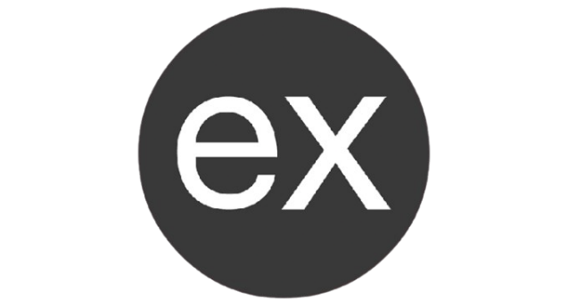
Express is important in Uni Demands because it simplifies backend development by providing fast and organized routing for APIs. It manages requests like user login, product control, orders, and notifications efficiently, making the server secure, lightweight, and easy to maintain.

- MongoDB:
MongoDB is a popular open-source, NoSQL database designed for high performance, scalability, and flexibility. Unlike traditional relational databases, MongoDB stores data in JSON-like documents using a flexible, schema-less model. This allows developers to work with dynamic and complex data structures more efficiently.

Key Points:
- NoSQL Database – MongoDB is a non-relational database that stores data in flexible, JSON-like documents instead of traditional tables.
- Schema-less Structure – Collections do not require a fixed schema, allowing dynamic fields and flexible data models.
- Document-Oriented – Each record is stored as a document (similar to a JavaScript object), making it intuitive for developers working with JavaScript/Node.js.
- High Performance – Designed for high-speed data operations, ideal for applications requiring fast reads and writes.
- Horizontal Scalability – Supports sharding, enabling the database to scale across multiple servers for large-scale applications.
- Integration with Mongoose – Easily integrates with Mongoose for schema validation, relationships, and advanced querying.
- Indexing Support – Offers powerful indexing features to speed up search queries and improve performance.
- Flexible Query Language – Allows complex queries, filtering, aggregation, and full-text search using JavaScript-like syntax.
- Cloud Support (MongoDB Atlas) – Offers a fully managed cloud solution for hosting MongoDB databases with automatic backups and scaling.
- Cross-Platform – Works seamlessly on Windows, macOS, Linux, and cloud platforms like AWS, Azure, and Google Cloud.

Importance of MongoDB in Project:
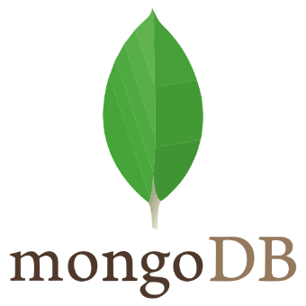
MongoDB is important in Uni Demands because it stores all system data—such as users, universities, departments, products, and orders—in a flexible and scalable database structure. Its document-based model allows fast data retrieval and smooth handling of large records, making the system reliable and easily expandable.

3.3 Tools Used:
- MongoDB Compass:
MongoDB Compass is the official graphical user interface (GUI) provided by MongoDB for visually exploring, managing, and analyzing the contents of a MongoDB database. It allows developers to interact with databases without writing complex queries manually, making it especially useful for testing, debugging, and development.

Key Points:
- GUI for MongoDB – Provides a graphical interface to interact with MongoDB databases without needing command-line queries.
- Visual Document Exploration – Allows viewing and editing of documents in a user-friendly format.
- Collection Management – Easily create, update, delete, and filter collections and documents.
- Real-Time Monitoring – Displays server performance statistics such as index usage, query performance, and database size.
- Aggregation Pipeline Support – Enables users to build and test complex aggregation stages visually.
- Index Management – Helps view and manage indexes to optimize database performance.
- Cross-Platform Tool – Available for Windows, macOS, and Linux.
- Ideal for Development – Makes testing, debugging, and inspecting data easier during the backend development phase.

Importance of MongoDB in Project:

MongoDB Compass is important in Uni Demands because it provides a visual interface to view and manage the database more easily. Through Compass, admins and developers can inspect collections, monitor records, run queries, and verify stored data without using the command line, making database management faster and more convenient.

- Postman:
Postman is a widely used API development and testing tool that provides a powerful and user-friendly interface to interact with backend services. It allows developers to send requests to APIs, inspect responses, and debug endpoints without building a frontend first.

Key Points:
- API Testing Tool – Allows developers to test, debug, and document RESTful APIs without needing a frontend.
- User-Friendly Interface – Provides an intuitive GUI to send HTTP requests (GET, POST, PUT, DELETE, etc.) and view responses.
- Supports Environment Variables – Enables the use of variables (e.g., base URLs, tokens) for easy testing across environments.
- JWT & Auth Integration – Supports various authentication methods, including JWT, OAuth, and API keys.
- Request Customization – Allows adding headers, body data (JSON, form-data), and query parameters.
- Collection & Folder Structure – Lets you organize related API requests into collections for better project management.
- Built-In Test Scripts – Provides scripting options for automated tests and response validation using JavaScript.
- Collaboration Friendly – Supports sharing APIs and environments with team members for collaborative development.

Importance of Postman in Project:
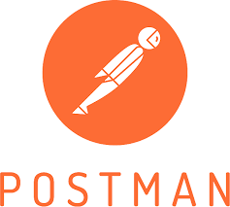
Postman is important in Uni Demands because it helps test and verify all backend APIs during development. With Postman, developers can send requests, check responses, debug issues, and ensure that endpoints like login, products, orders, and payments are working correctly before connecting them to the frontend.

- GitHub:
GitHub is a web-based platform that provides version control and collaborative development using Git, a distributed version control system. It enables developers to store code repositories online, manage changes, track revisions, and collaborate with team members in real time.

Key Points:
- Version Control Platform – Built on Git, GitHub helps track changes in code and manage multiple versions efficiently.
- Cloud-Based Code Hosting – Stores your code online, making it accessible from anywhere.
- Collaboration-Friendly – Supports real-time collaboration using branches, pull requests, and issue tracking.
- Code Backup & Recovery – Acts as a secure backup for your entire project, preventing data loss.
- Commit History Tracking – Maintains a full history of code changes, helping developers understand who changed what and why.
- Branching and Merging – Allows multiple developers to work on different features or fixes simultaneously.
- Supports Open Source & Private Projects – Projects can be public for open-source contribution or private for internal use.
- Integrated with CI/CD Tools – Easily connects with deployment, testing, and automation tools for modern DevOps workflows.
- Community and Documentation – Offers a strong developer community and built-in tools like README files and Wikis for project documentation.
Importance of Visual Studio Code in Project:

GitHub is important in Uni Demands because it provides a secure platform for storing, managing, and version-controlling the project source code. It enables collaboration, backup, and tracking of changes, making development more organized and ensuring that the code remains safe and accessible at all times.

CHAPTER 4 – Software Development Life Cycle (SDLC) Model

4.1 Introduction to SDLC:
The Software Development Life Cycle (SDLC) is a systematic process used for developing software that ensures quality, efficiency, and structure in the development workflow. It defines the stages involved in building software applications, from initial planning and requirement gathering to design, development, testing, deployment, and maintenance.
By following a well-defined SDLC model, teams can reduce project risk, improve resource management, and deliver a high-quality product within a specified time frame. Each phase in the SDLC has specific deliverables and documentation, making the process more manageable and transparent.
In the context of the UNi Demands project, the SDLC model served as a guideline to execute the project step by step, ensuring proper planning, structured coding, and successful deployment of the full-stack web application.
4.2 SDLC Model Used:
For the development of the UNi Demands project, the Waterfall Model of SDLC was followed. The Waterfall Model is a linear and sequential approach where each phase of the software development process flows logically into the next. This model is suitable for projects where requirements are clearly understood from the beginning and minimal changes are expected during development.
Each stage in the Waterfall Model must be completed before the next one begins, making it easy to manage and document progress. This model was chosen for UNi Demands to ensure a structured and organized development process, with well-defined goals at every stage—from requirement gathering to deployment.
The Waterfall approach provided clarity and discipline during the development of the system's Admin and Employee panels, helping maintain a consistent flow of progress without overlaps or confusion.

4.3 Phases of SDLC:
The development of UNi Demands was carried out in a structured sequence, following the key phases of the Waterfall SDLC model. Each phase contributed to building a stable, scalable, and maintainable employee task management system.
4.3.1 Requirement Analysis
In this phase, detailed discussions were held to understand the project's functional and non-functional requirements. The system needed to support role-based access (Admin and Employee), task assignment and tracking, performance monitoring (coins/warnings), leave handling, and secure login. Clear documentation of these requirements laid the foundation for the next phases.
4.3.2 System Design
Based on the gathered requirements, the overall architecture of the system was designed. This included:
- Designing the database schema using MongoDB and Mongoose
- Planning RESTful API routes in Express.js
- Structuring frontend components using React.js
- Designing the UI with responsiveness in mind using Bootstrap
4.3.3 Implementation
This phase involved the actual coding and development:
- Backend was developed using Node.js and Express.js
- Frontend was developed using React.js
- APIs were created for task management, user authentication, leave processing, and performance tracking
- MongoDB was used to store data, such as users, tasks, and rewards
The code was written in VS Code and version-controlled using GitHub.

4.3.4 Testing
After implementation, thorough testing was done using tools like:
- Postman for API testing
- Console debugging for frontend validation
- MongoDB Compass for checking data integrity
Manual and functional testing ensured that each module performed as expected and edge cases were handled.
4.3.5 Deployment
The system was prepared for deployment. Backend services and the frontend were tested on different machines to ensure cross-device functionality. The folder structure, port configuration, and environment variables were set for smooth running of the project on any system.
4.3.6 Maintenance:
As part of the maintenance phase, minor changes and improvements were made based on testing feedback. The system allows for future scalability, such as adding customer roles, notifications, or advanced reporting features.

Chapter 5: System Design and Requirements
5.1 System Architecture
The architecture of UNi Demands follows a MERN stack model (MongoDB, Express.js, React.js, Node.js), built using a client-server approach.
- Frontend (React.js): Handles the user interface for Admin and Employee panels using components and Bootstrap for responsiveness.
- Backend (Node.js + Express.js): Manages routing, business logic, API creation, and validation. It processes requests from the frontend and interacts with the database.
- Database (MongoDB): Stores all project data including users, tasks, performance records, and leave applications. Connected via Mongoose for schema management.
- API Communication: Frontend communicates with the backend using RESTful APIs. Tools like Postman are used to test these APIs.
- Development Tools: VS Code for coding, GitHub for version control, and MongoDB Compass for viewing database records.
5.2 Data Flow Diagrams (DFDs):
Data Flow Diagrams (DFDs) visually represent the flow of data through the system. For the UNi Demands project, Level 2 DFDs are included to illustrate detailed processes within the Admin and Employee panels. These diagrams show how tasks, authentication, leaves, and performance data move between users, the system, and the database
5.2.1 Admin Panel
Admin Panel illustrating data flow for category, subcategory, project, team, task, and performance (reward/warning) management.

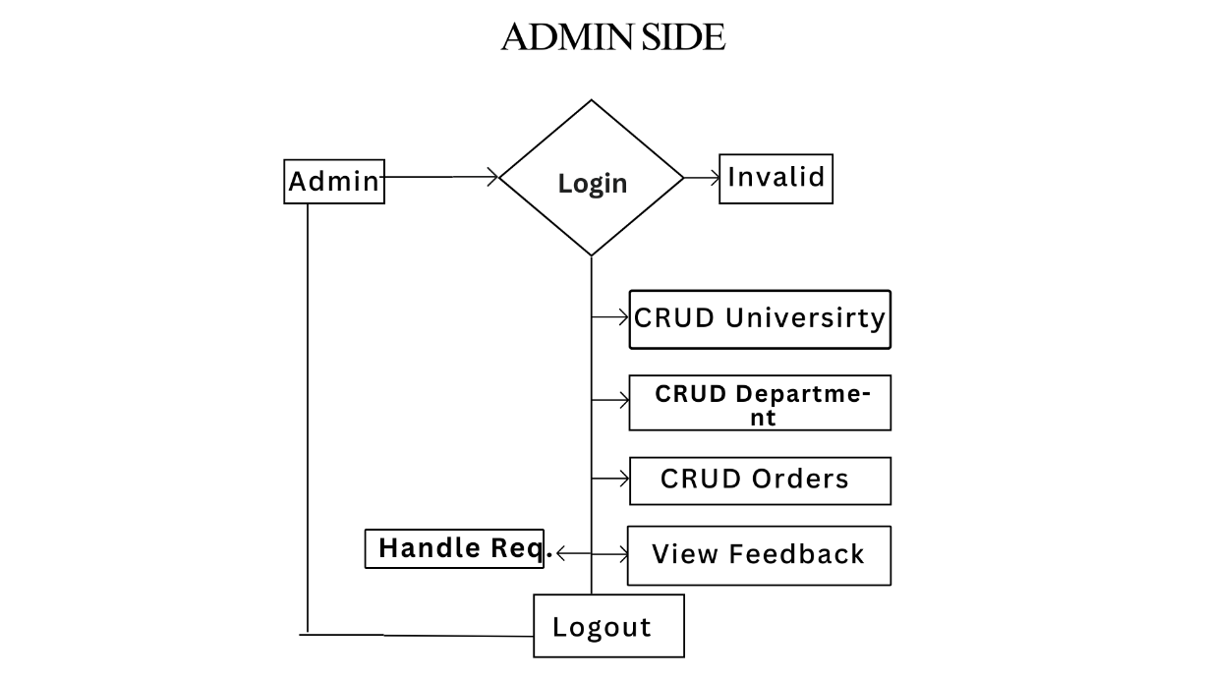

5.2.1 User Panel
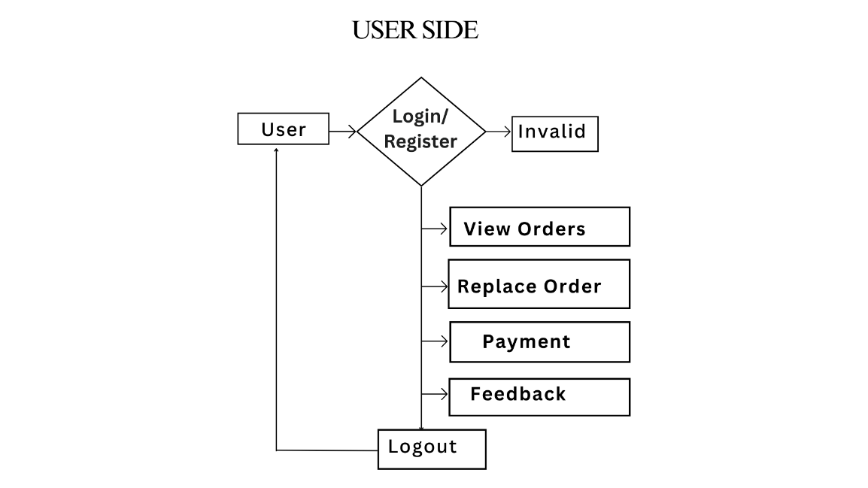
DFD of User Panel showing the flow for task viewing, submission, profile management, and performance tracking.

5.3 System Requirements:
The development and execution of the UNi Demands project require specific hardware and software components to ensure smooth performance and compatibility. Below are the minimum and recommended requirements:
5.3.1 Hardware Requirements:
Component | Minimum Requirement | Recommended Requirement
Processor | Intel Core i3 | Intel Core i5 or above
RAM | 4 GB | 8 GB or more
Hard Disk | 100 GB (free space) | 256 GB SSD
Monitor | 1024 × 768 resolution | Full HD (1920 × 1080)
Input Devices | Keyboard and Mouse | Standard Input Devices
Internet Connection | Required for testing & deployment | Stable High-Speed Connection
5.3.2 Software Requirements:
Software | Details / Version
Operating System | Windows 10/11, Ubuntu 20+, or macOS
Code Editor | Visual Studio Code
Backend | Node.js (v16+) with Express.js
Frontend | React.js (with Vite or Create React App)
Database | MongoDB (Local or MongoDB Atlas)
Database GUI | MongoDB Compass
API Testing Tool | Postman
Version Control System | Git and GitHub
Browser | Google Chrome / Mozilla Firefox
Terminal/Command Line | Windows CMD / Bash / PowerShell

Chapter 6: Testing, Maintenance, and Results
6.1 Testing:
Testing ensures that all modules of the project function as expected and meet the specified requirements. In the UNi Demands project, multiple types of testing were performed to validate functionality, performance, and reliability.
6.1.1 API Testing with Postman
All backend APIs developed in Node.js and Express.js were tested using Postman. Each route (GET, POST, PUT, DELETE) was tested with valid and invalid inputs to verify:
- Data validation
- Status codes (200, 201, 400, 422, 500)
- Response structure
- Authentication using JWT tokens
6.1.2 Module Testing
Each panel (Admin and Employee) was tested separately to ensure the UI components and logic were working properly:
- Admin side: task creation, employee handling, warnings/coins
- Employee side: viewing tasks, submitting tasks, requesting leave

6.1.3 Validation Testing
Field validations were tested on both frontend and backend:
- Required fields (e.g., email, password, task title)
- Minimum password length
- Unique email/user check
- Date and time validations

6.1.4 Error Handling Tests
Test cases were created to simulate invalid requests and server errors. Custom error messages and proper HTTP status codes were returned for:
- Missing fields
- Unauthorized access
- Invalid data formats

6.2 Maintenance
Maintenance is a crucial phase of the software development life cycle. It ensures the system remains functional, secure, and scalable after deployment. The UNi Demands project includes basic and ongoing maintenance strategies to address bugs, improve features, and prepare for future enhancements.

6.2.1 Bug Fixes and Enhancements
During testing, several bugs and functional issues were identified and resolved:
- Fixed API validation errors for login, task creation, and leave requests.
- Corrected UI alignment and responsiveness using Bootstrap.
- Handled duplicate entries and invalid task IDs using backend validation logic.
- Implemented better error handling in API responses to improve user understanding.

6.2.2 Future Scope and Scalability
To ensure the project can grow and adapt to future needs, the following enhancements are planned:
- Addition of a Customer Panel for future client interaction.
- Integration of Email or SMS notifications for task updates and approvals.
- Implementing real-time updates using technologies like Socket.IO.
- Role-based access enhancements (Team Leads, HR, etc.).
- Deployment on a live server or cloud environment for broader access.

6.3 Result
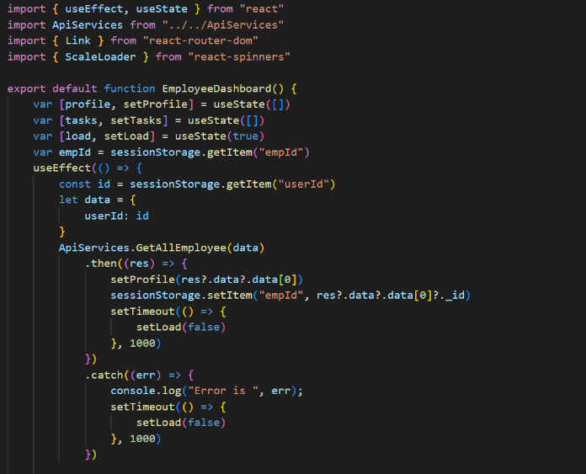
6.3.1 Code:
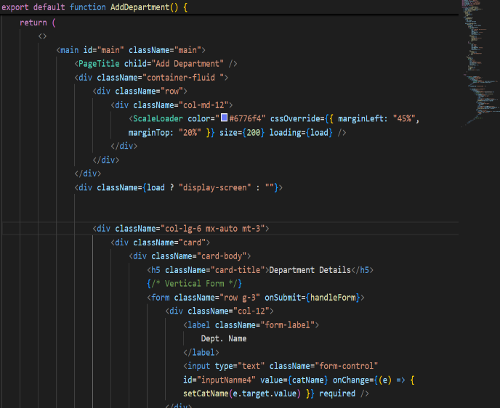

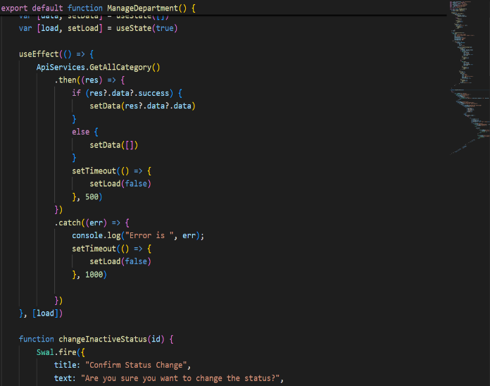
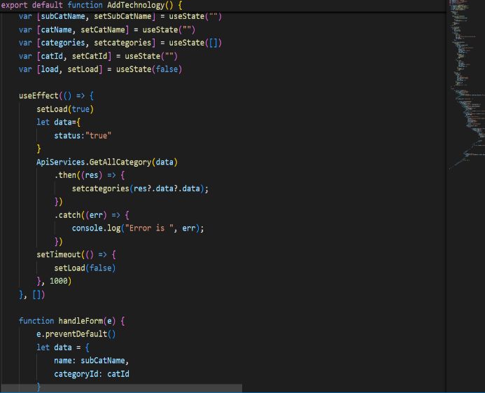

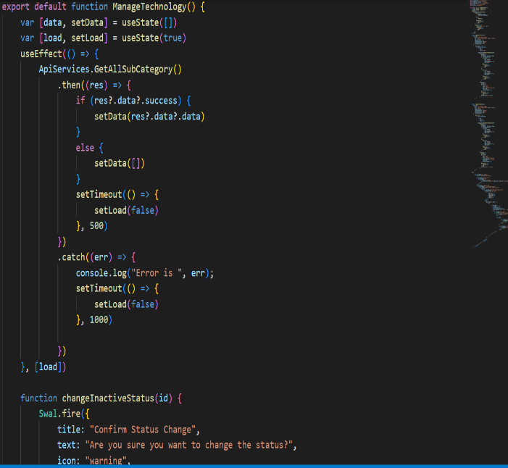
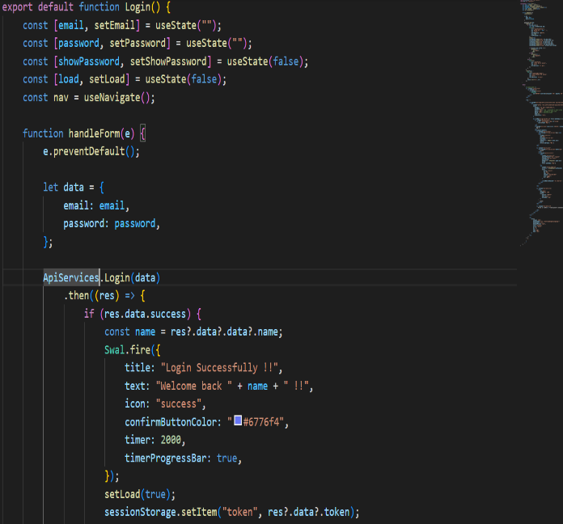

6.3.2 Images of UI Design
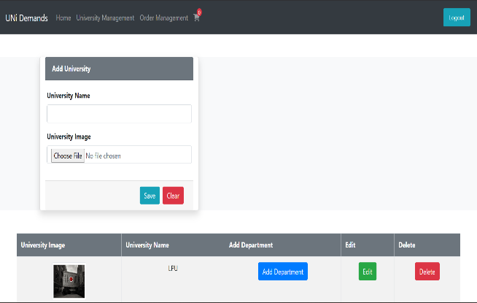
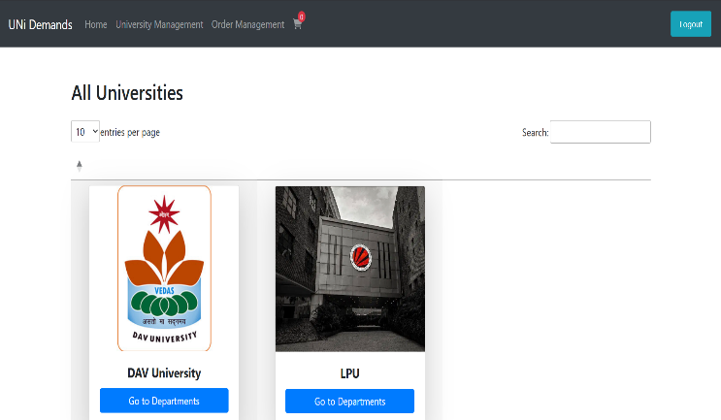

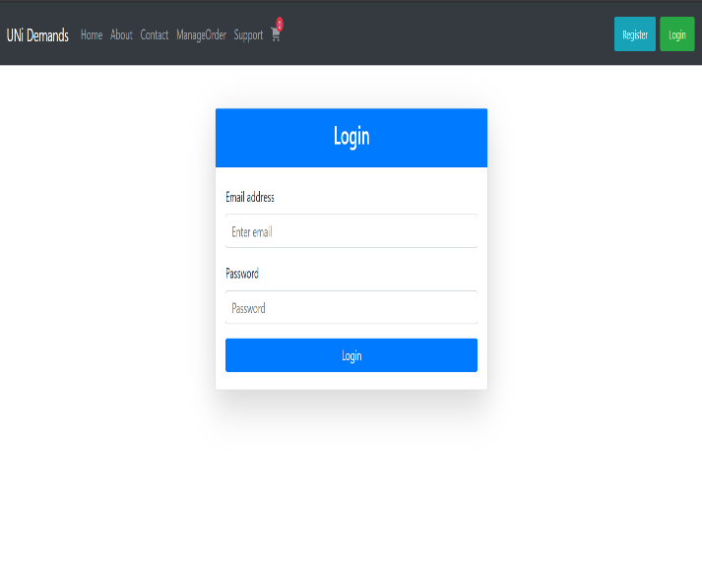
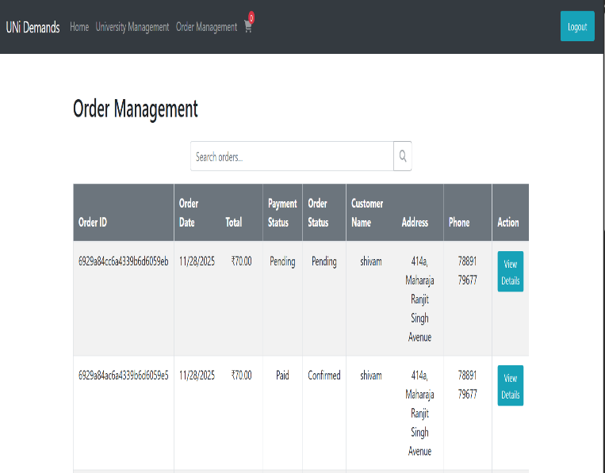

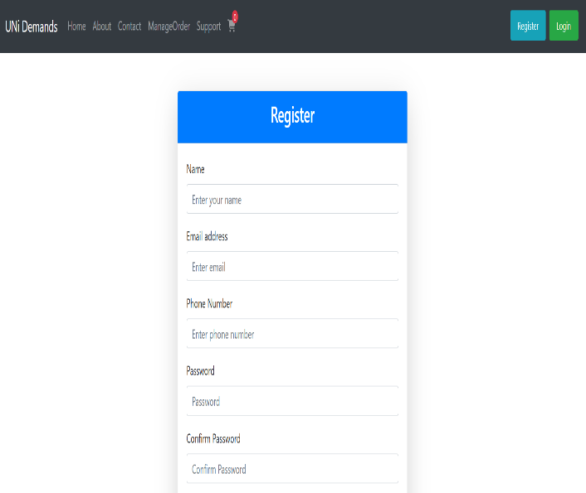
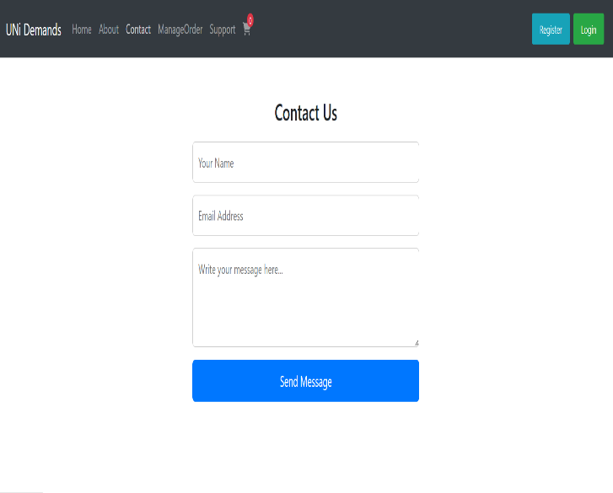

Chapter 7: Conclusion

7.1 Conclusion
The UNi Demands project successfully delivers an efficient and organized system for managing employee tasks, performance tracking, leave handling, and team coordination. Built using the MERN stack, it combines a responsive frontend, a robust backend, and a scalable NoSQL database to provide role-based access and seamless task workflows for both Admin and Employee panels.
Throughout the development process, industry practices such as modular coding, API testing, and real-time validations were implemented to ensure reliability and user experience. The project can easily be extended in the future to support new roles, integrate notifications, and connect to external services.
Overall, UNi Demands serves as a strong foundation for real-time employee task management and highlights the power of full-stack web development in solving real-world organizational challenges.

References
Here are some sources and tools referred to during the development of the project:
- Node.js Documentation
- Express.js Guide
- MongoDB Docs
- Mongoose Docs
- React.js Documentation
- Bootstrap Framework
- Postman API Testing
- MongoDB Compass
- GitHub
- W3Schools
- Stack Overflow

